January 29, 2025

Dear Chair and Members of the Arts and Sciences Curriculum Committee:

On January 10, 2025, the Arts and Humanities Subcommittee 2 reviewed a request from the American Sign Language (ASL) program to revise the ASL minor. As noted in the request, the program has grown exponentially and undergone significant expansion of curriculum and personnel since minor was first approved in 2020. Thus, the program wishes to recognize those changes by updating the minor in the following ways:

* Reduction of the required number of courses in the core (by 3 credit-hours, from 9 to 6 credit-hours)
* Expansion of the number of elective courses taken by students (by 3 credit-hours, from 3 to 6 credit-hours)
* Adding new courses to the electives category (including a study-abroad option up to 6 ch)
* Deleting 3 courses from the elective category

Students who have already declared the minor will not be affected negatively by these changes.

A&H Subcommittee 2 voted unanimously to approve the request with no contingencies and the proposal is now advanced to the ASCC with a motion to approve.

Sincerely,

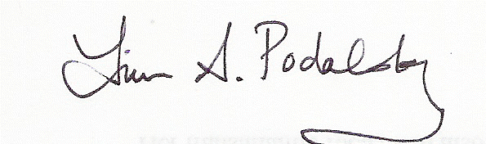

Laura A. Podalsky

Professor

Department of Spanish and Portuguese

Chair, ASCC A&H Subcommittee 2